
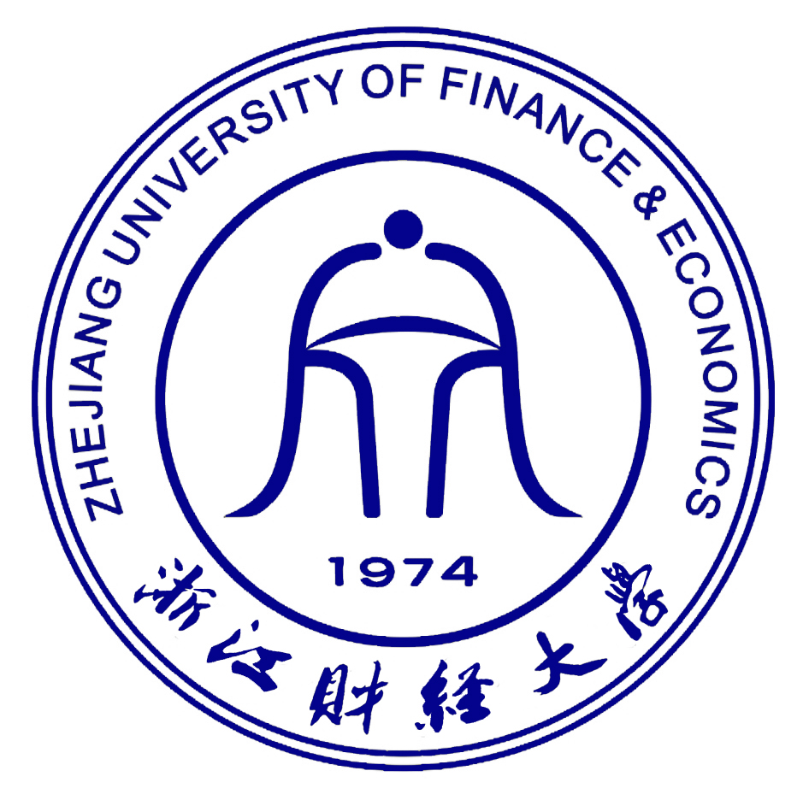
Thesis Proposal

Title： The Role Of Social Media Channels In Influencing Buying Behavior in China: Weibo

Name: Polyakov Vyacheslav
ID number: 172023010168
Supervisor: 赵卓嘉
School: International School
Major: International Economics and Trade
Year: 2017

Date: 12/02/2020
- 论文（设计）选题的依据（选题的目的和意义、该选题国内外的研究现状及发展趋势等）The basis of the research (the purpose and significance of the research, Research status and development trend at home and abroad etc.):

The aim of this social investigation is to identify and measure the influence of promoting a business through online media channels on the consumers’ buying behaviour. In this research the focus is specifically on the Chinese social media platforms, mainly Weibo, and their potential for marketing to Chinese customers.

In the modern world, both in my home country and abroad, social media has proven to be an extremely potent platform for marketing. According to a 2018 survey by Marketing and Sociological Research Institute “Elim”, social network applications have already become the most effective advertisement tool among people in Kazakhstan, with Instagram being the most popular one (36.2%). The other major platforms used by Kazakhstani people are WhatsApp (15.2%) and Facebook (14.8%), while only 10.2% of respondents stated that they don’t use social media at all, which proves its widespread influence inside the country. Hence the technological advancement and the gradual shift that occurred in the society from receiving the most information by watching television and reading newspapers to consuming most content online, the research on the topic of digital marketing is experiencing a rising trend in the last few years.

As for the research papers written in English, the world has to offer a plenty of literature on the subject of social media, however the marketing opportunities presented by the phenomenon are still in the beginning of being thoroughly investigated. A comprehensive study by Information System Frontiers, a journal of research and innovation, gives an overview of the development of social media studies. A total of 132 articles from the Web of Science database were analyzed in their paper “Advances in Social Media Research: Past, Present and Future”. The study revealed that while among the reviewed articles were papers researching various topics related to social media, only “around 13 publications studied the use of social media as a marketing tool”.

Nevertheless, with more and more businesses integrating into the digital environment, a lot more research on the topic has been done recently. This is especially true in the Chinese market: since so many essential services, such as payment, shopping, ordering food, and even laundry have been digitized, it has become easier to use internet applications for promotion. Even though most of the outside world’s online applications, such as Google, YouTube, Facebook, Instagram, Twitter are all blocked in China due to censorship, popularity of the domestic social media platforms are on the rise, which, combined with the foreign businesses interest in the Chinese market due to the rising economy, serves as a terrific opportunity for more research on the topic of digital marketing.

It is hoped that at the end of the investigation there will be a clear indication of the potential of Chinese social media channels (Weibo in particular) in assisting both local and foreign businesses, that are planning to penetrate the Chinese market, in promotion, as well as statistical identification of what kind of target audience this marketing campaign would be the most suitable for and what kind of tactics would be the most effective. This study also aims to provide a foundation for further academic research in the field of international online marketing.

- 论文（设计）的主要研究内容及预期目标Research contents and expected objectives:

The main objectives of this study are to analyze Weibo as an online marketing tool for Chinese consumers, compare it to different approaches to advertising including the other local social media platforms and assess the degree of influence it has on buying behaviour in China. Furthermore the research aims to identify the key consumer age groups that marketing in Weibo can target. All of this is planned to be done by testing the following hypotheses:

- Weibo As A Social Media Is The New Age Platform For Influencing The Consumer Buying Behavior.

a. Social media is more potent than the rest of the media vehicle in influencing buying behavior.

b. Weibo is more potent in influencing buying behavior than all other social media channels.

c. Weibo as a social media provides different environment for influencing buying behavior.

- Weibo Is Potent In Influencing Consumer Behavior Only To The Younger Generation.

- It is only the young adults and teenagers who could be influenced by marketing through Weibo.

Considering the popularity and the functionality of the online platform, the results are expected to be in the favour of Weibo providing a different environment for marketing as well as being one of the most potent social media platforms in terms of affecting consumers’ buying behaviour in China and completely outrunning the rest of the media vehicle. However it is also expected that people highly influenced by online marketing in Weibo will mostly be from the younger generation, since that is the layer of society among which the online technology is used the most widely.
- 论文（设计）的主要研究方案（拟采用的研究方法、准备工作情况及主要措施）Research plan (research methods, preparation and measures):

The primary research methods for this study are survey and linear regression analysis. First, an online questionnaire will be designed and suggested to people of different age groups in China. Secondly, the sample will be analyzed by its size and based on the personal information of the individual respondents. Next, the data retrieved from the responds will be compared between different groups of respondents. That will show whether or not Weibo provides a different environment for online advertising, and surpasses the other media vehicles as well as its rival social media platforms. Finally, a linear regression model will be built to find the correlation between the age of the respondents and the significance of social media influence on their buying behaviour.

The survey is planned to be conducted on Wenjuan (www.wenjuan.com), a Chinese commercial online survey service provider, with advertisement disseminated via WeChat (www.wechat.com).
The questionnaire shell be designed with a simple purpose: to find out whether or not Chinese consumers are more influenced by Weibo as a marketing platform rather than by other media vehicles and what age groups are affected the most. Since the need for accurate quantitative data, the respondents will be provided with closed-ended questions, such as multiple choice and checkbox questions.
A variety of questions will be asked to measure the influence of the online marketing on the consumers, such as where do respondents get the most information about the products and how often to they make a purchase after being introduced to the product. Every respondent will be asked to provide information about their age at the end of the survey.

你可以开始设计问卷了 把问卷放上去可以更完整， 下面的文献格式弄好后，你可以发赵老师看一下，有没有问题，如果她说ok那就没问题了。另外写论文千万不要抄袭，会查重的，重复率过高论文就过不了。
四、主要参考文献Reference: 参考文献的格式好像不太对

- Marketing and Sociological Research Institute “Elim”. “Advertising efficiency and popular social networks in Kazakhstan”
（按照将首字母按ABCD顺序排列）[1]Kapoor, K.K.1;Tamilmani, K.2;Rana, N.P.2;Patil, P.2;Dwivedi, Y.K.2;Nerur, S.3.Advances in Social Media Research: Past, Present and Future[J].Information Systems Frontiers.2018,Vol.20(No.3)：531-558.
- Information System Frontiers. “Advances in Social Media Research: Past, Present and Future”

- Alessia Rezzano. “Analysis of Chinese consumers behaviour and social media communication: A focus on luxury fashion brands”

- Liyu Hu, Kicki Ly. “Social media in China – a study of attitudes, behaviors and gender differences among Chinese students”

- Huiying Yu.“The effect of social media comment on Chinese consumers' attitude toward the brand”

- Xiao Fei. “Social Media in Chinese Tourism Industry -The Use of Weibo by Tourist Sites in China”

Liwei Chen. ”The influence of social media on consumer behavior”

Arianna De Zuani. ’Digital Marketing in China: An analysis of the social media strategy of Tod’s Group’

University of Rhode Island. “Social Media as a Marketing Tool: A Literature Review”

- Bampo, Mauro, Michael T. Ewing, Dineli R. Mather, David Stewart, and Mark Wallace. 2008. “The Effects of the Social Structure of Digital Networks on Viral Marketing Performance.”

- Cox, Shirley A. 2010. “Online Social Network Member Attitude Toward Online Advertising Formats.”

- Di Pietro, Loredana and Elenora Pantano. 2012. “An Empirical Investigation of Social Network Influence on Consumer Purchasing Decision: The Case of Facebook.”

- Ferguson, Rick. 2008. “Word of mouth and viral marketing: taking the temperature of the hottest trends in marketing.”

- Golan, Guy J. and Lior Zaidner. 2008. “Creative Strategies in Viral Advertising: An Application of Taylor’s Six-Segment Message Strategy Wheel.”

- Mangold, Glynn W., and David J. Faulds. 2009. “Social Media: The New Hybrid Element of the Promotion Mix.”

- Muñiz, Albert M. and Hope Jensen Schau. 2007. “Vigilante Marketing and Consumer Created Communications.”

五、论文（设计）研究工作进展安排Progress and arrangement of the research:

This study will be conducted between January 2021 and March 2021.
All the relevant theory on the topic to support the research will be collected and organized before January 10.
The questionnaire will be designed and uploaded online before January 20.
The survey is planned to be conducted between January 20 to February 20.
The results will be assessed and recorded in the first draft before March 15.

六、指导老师意见Comments of supervisor:

指导老师签字Signature of supervisor:

月M: 日D: 年Y:
七、学院论文（设计）领导小组意见Comments of school:

学院（盖章）School’s seal:

月M: 日D: 年Y:
This form is in two copies which should be kept by International school and supervisor.

